Competition Format for SEQ – 2/23 – 25/2024

Location: Georgia International Convention Center Courts 1 – 38

18 Open – GICC 8-10, 13-15, A.M. Wave
18 teams will be competing in the 18 Open Division. They will be organized into three pools of six teams each. Upon completion of pool play the 1st, 2nd, 3rd, and 4th place finishers of each pool will advance to the next round, where they will be organized into four, three-team Gold Medal Pools. Winners of each Gold Pool will advance to the Championship Bracket. The third-place match will be played, if necessary.
Upon completion of pool play, 5th and 6th place finishers will compete in a crossover match. All 5th and 6th place finishers will play in the single-elimination Silver Bracket on Sunday.

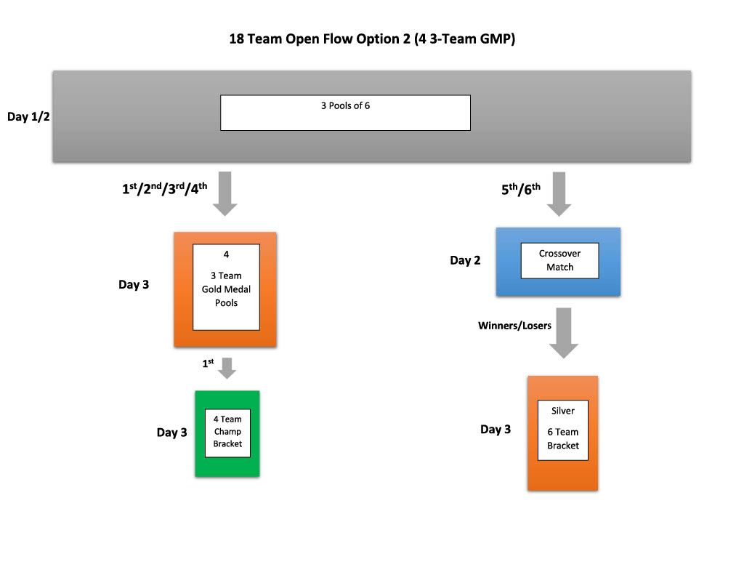

18 USA – GICC 6-10, 13-15, P.M. Wave
The 18 USA division will have 32 teams. They will be organized into eight pools of four teams. 1st and 2nd place finishers in the four-team pools will advance to round 2. 3rd and 4th place finishers will fall from contention.
Thus 16 teams will advance to round 2. They will be organized into four pools of four teams. First and second place finishers will advance to an 8-team single elimination Championship Bracket. The top two finishers will play for the Championship, with semifinalists playing for 3rd place and a bid.
The third-place finishers will compete in the Silver Bracket. The fourth-place finishers will play in the Bronze Bracket.
The sixteen teams that fall out of contention will be organized into four, 4-team pools on Saturday. First-place finishers in those pools will compete in Flight 1. Second-place finishers will compete in Flight 2. Third-place finishers will play in Flight 3. Fourth-place finishers will compete in Flight 4.

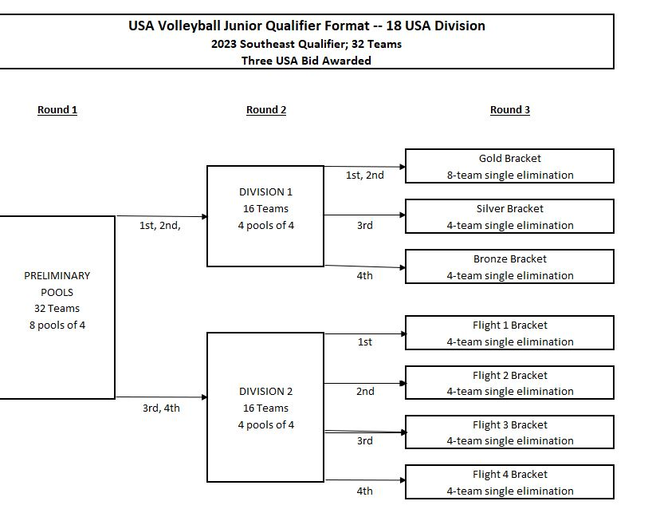

18 Liberty – GICC 16-18, 21-25, P.M. Wave
The 18 Liberty division will have 31 teams. They will be organized into seven pools of four teams and one pool of three teams. Teams in the 3-team pool will automatically play a 3rd set to 25. 1st and 2nd place finishers in each pool will advance to round 2. 3rd and 4th place finishers will fall from contention.
Thus 16 teams will advance to round 2. They will be organized into four pools of four teams. First and second place finishers will advance to an 8-team single elimination Championship Bracket. The top two finishers will play for the Championship.
The third-place finishers will compete in the Silver Bracket. The fourth-place finishers will play in the Bronze Bracket.
The fifteen teams that fall out of contention will be organized into three, 4-team pools and one, 3-team pool on Saturday. Teams in the 3-team pool will automatically play a third set to 25. First-place finishers in each pool will compete in Flight 1. Second-place finishers will compete in Flight 2. Third-place and fourth-place finishers will play in Flight 3.

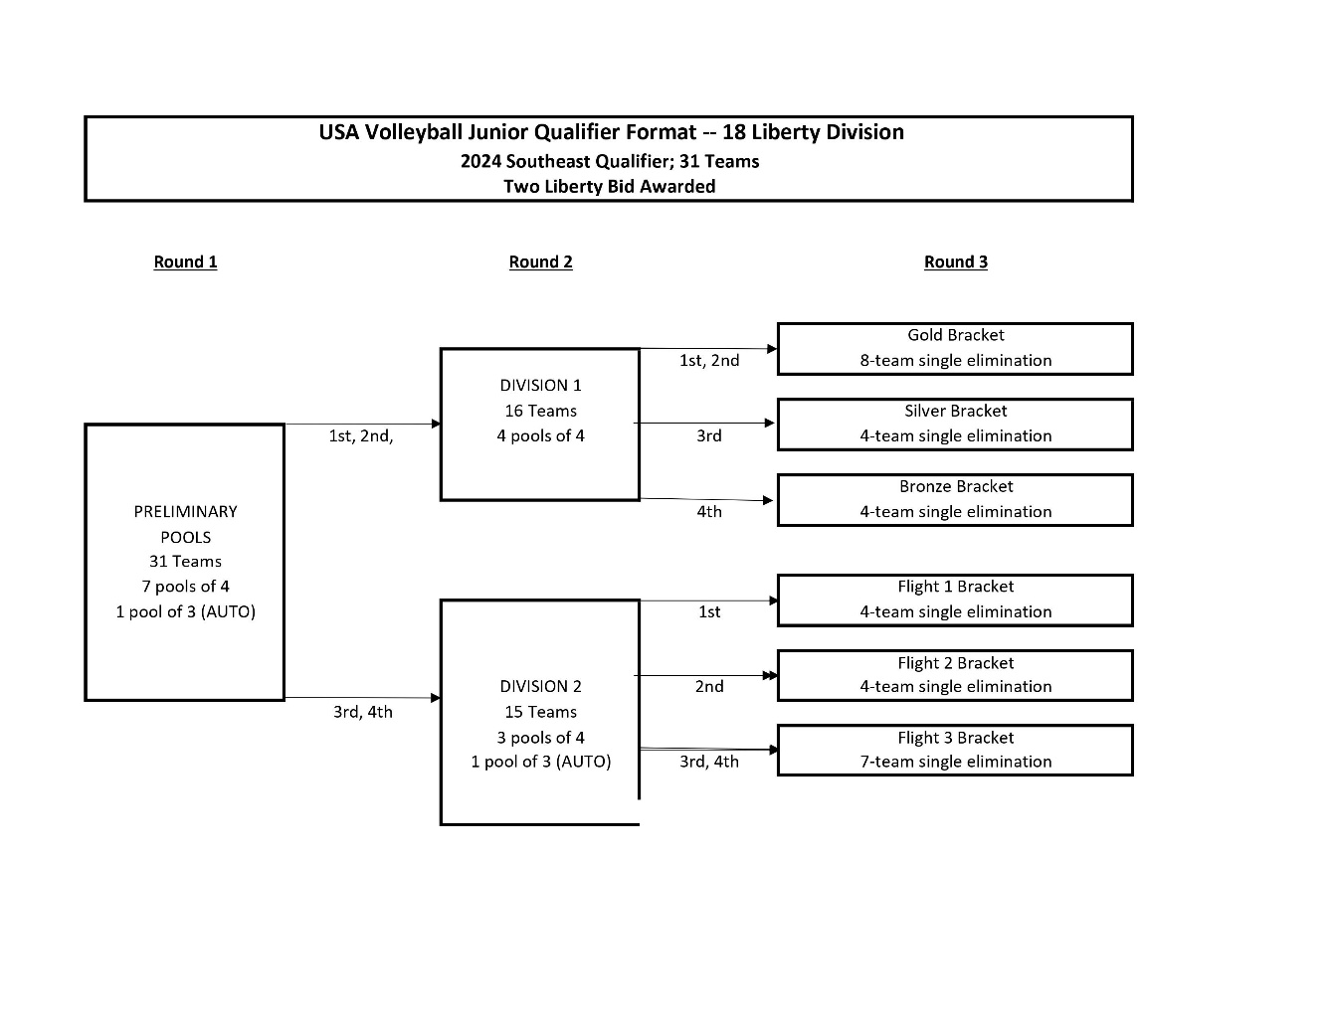

18 American – GICC 1-3, 5-7, 16-18, 21-25, A.M. Wave
56 teams have entered the 18 American Division. They will be organized into fourteen pools of four teams.
The top two finishers in each pool advance to round two. The teams in contention will be organized into seven, four-team pools. First and second place finishers of pools in contention will advance to a 14-team, single-elimination bracket. The third-place finishers in each pool, in addition to the top 4th place finisher based on match %/set%/point%/coin flip (NOT based on seed) will play in the Silver Bracket. The remaining 4th place finishers will compete in the Bronze Bracket.
The twenty-eight teams that fall out of contention after round 1, will be organized into seven, 4-team pools in round 2. The first-place finishers in each pool, in addition to the top 2nd place finisher based on match %/set%/point%/coin flip (NOT based on seed) will compete in either Flight 1A or Flight 1B. The remaining 2nd place finishers will play in Flight 2. Third-place finishers in each pool, in addition to the top 4th place finisher based on match %/set%/point%/coin flip (NOT based on seed) will compete in either Flight 3A or Flight 3B. The remaining 4th place finishers will compete in Flight 4.
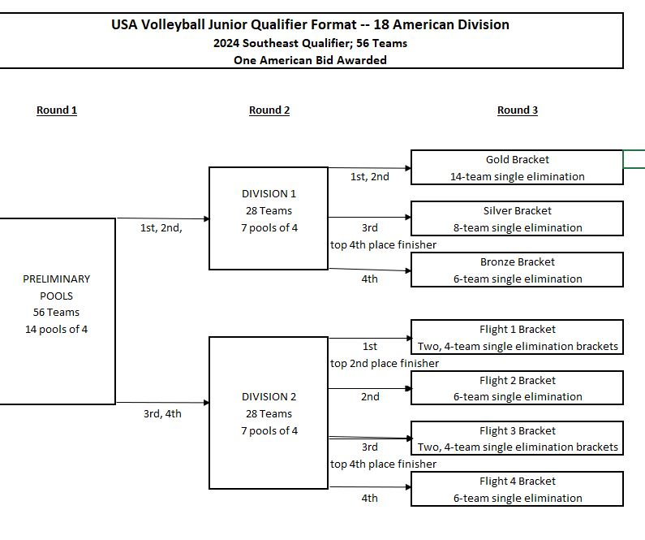

17 Open – GICC 21-25, P.M. Wave
There are twenty teams registered for the 17 Open division. Teams will be organized into five, 4-team pools. Upon completion of pool play, the top two finishers in each pool, in addition to the top two, 3rd place finishers based on match %/set%/point%/coin flip (NOT based on seed) will advance to the Gold Bracket on Sunday. Remaining third-place finishers and fourth-place finishers will compete in either the Silver A or Silver B Bracket. First-round losers in bracket play will compete in a consolation match.

16 Open – GICC 20, 26-30, A.M. Wave
There are twenty-four teams registered for the 16 Open division. Teams will be organized into six, 4-team pools. The top two finishers in each pool will advance to Sunday’s Gold Bracket. Third-place finishers will play in either the Silver A or Silver B Pool on Sunday. Fourth-place finishers will compete in either the Bronze A or Bronze B Pool on Sunday. First-round losers in bracket play will compete in a consolation match.

15 Open – GICC 4, 11, 12, 19, 20, 36, P.M. Wave
There are twenty-four teams registered for the 15 Open division. Teams will be organized into six, 4-team pools. The top two finishers in each pool will advance to Sunday’s Gold Bracket. Third-place finishers will play in either the Silver A or Silver B Pool on Sunday. Fourth-place finishers will compete in either the Bronze A or Bronze B Pool on Sunday. First-round losers in bracket play will compete in a consolation match.

14 Open – GICC 4, 11, 12, 19, 36, A.M. Wave
There are twenty teams registered for the 14 Open division. Teams will be organized into five, 4-team pools. Upon completion of pool play, the top two finishers in each pool, in addition to the top two, 3rd place finishers based on match %/set%/point%/coin flip (NOT based on seed) will advance to the Gold Bracket on Sunday. Remaining third-place finishers and fourth-place finishers will compete in either the Silver A or Silver B Bracket. First-round losers in bracket play will compete in a consolation match.

13 Open – GICC 31-35, P.M. Wave
There are twenty teams registered for the 13 Open division. Teams will be organized into five, 4-team pools. Upon completion of pool play, the top two finishers in each pool, in addition to the top two, 3rd place finishers based on match %/set%/point%/coin flip (NOT based on seed) will advance to the Gold Bracket on Sunday. Remaining third-place finishers and fourth-place finishers will compete in either the Silver A or Silver B Bracket. First-round losers in bracket play will compete in a consolation match.

12 Open – GICC 31-33, A.M. Wave
There are twelve teams registered for 12 Open. Teams will be organized into three, 4-team pools. The top two finishers in each pool will advance to Sunday’s Gold Bracket. Third-place finishers will compete in the Silver Pool on Sunday. Fourth-place finishers will play in Sunday’s Bronze Pool. First-round losers in bracket play will compete in a consolation match.

16/17 Power – GICC 26-30, P.M. Wave
There are twenty teams registered for the 16/17 Power division. Teams will be organized into five, 4-team pools. Upon completion of pool play, the top two finishers in each pool, in addition to the top two, 3rd place finishers based on match %/set%/point%/coin flip (NOT based on seed) will advance to the Gold Bracket on Sunday. Remaining third-place finishers and fourth-place finishers will compete in either the Silver A or Silver B Bracket. First-round losers in bracket play will compete in a consolation match.

14/15 Power – GICC 34, 35, 37, A.M. Wave and 37, 38, P.M. Wave
There are twenty-four teams registered for the 14/15 Power division. Teams will be organized into six, 4-team pools. The top two finishers in each pool will advance to Sunday’s Gold Bracket. Third-place finishers will play in either the Silver A or Silver B Pool on Sunday. Fourth-place finishers will compete in either the Bronze A or Bronze B Pool on Sunday. First-round losers in bracket play will compete in a consolation match.

